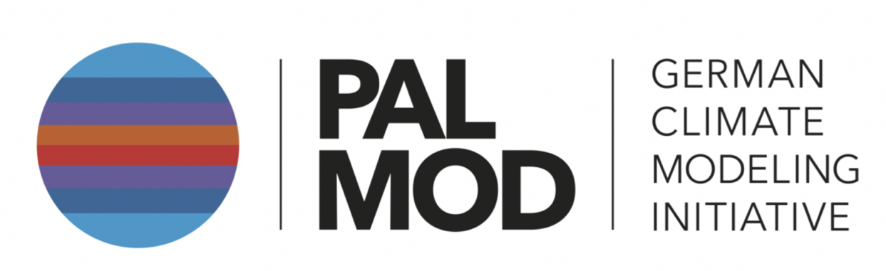

**2rd General Assembly, PalMod Phase III**

**Mo. 16.06.2025**

|  |  |  |  |
| --- | --- | --- | --- |
| 10:00 – 11:00 | *Welcome Coffee* |  | 60 min |
| **11:00 – 12:50** |  |  | **120 min** |
|  | Welcome and Intro | Coordinators | 15 min |
|  | Housekeeping | K. Fieg | 5 min |
|  | **REPORTING PalMod III** |  |  |
|  | Overview CC 1,2,3 |  | 20 + 5 min |
|  | Highlight Talk CC |  | 15 + 5 min |
|  | Overview WG3 |  | 20 + 5 min |
|  | Highlight Talk WG3 |  | 15 + 5 min |
|  | *Discussion / Buffer* |  | *10 min* |
| 13:00 – 14:00 | *Lunch* |  |  |
| **14:00 – 15:40** | **Cont. REPORTING PalMod III: WG2** |  | **100 min** |
|  | Overview WG2 |  | 20 + 5 min |
|  | Highlight Talk WG2 |  | 15 + 5 min |
|  | Overview WG1 |  | 20 + 5 min |
|  | Highlight Talk WG1 |  | 15 + 5 min |
|  | *Discussion / buffer* |  | *10 min* |
| 15:40 – 16:10 | *Coffee* |  | 30 min |
| 16:10 – 16:45 | Introduction & Status to IOSC 2026 |  | 35 min |
| **16:45 – 18:00** | **Poster Session Part 1** |  | **75 min** |
| ***18:30 - xx*** | ***Social Event @ tba*** |  |  |

**Tue, 17. 06.2023**

|  |  |  |  |
| --- | --- | --- | --- |
| **9:00 – 10:00** | Plenary discussion on IOSC (Structures, Topics and timeline) |  | 60 Min |
| 10:00 – 10:30 | Coffee |  |  |
| **10:30 – 12:00** | **Poster Session Part 2** |  | **90 min** |
| *12:00 – 13:00* | *Lunch* |  |  |
| **13:00 – 15:00** | **The integrative perspective of PalMod** |  | **120 min** |
|  | Reporting on the Status of the PalMod Special Issue |  | 15 min |
|  | Model intercomparison in PalMod |  | 20 + 5 min |
|  | The Antarctic Perspective |  | 20 + 5 min |
|  | Across models: fully coupled from 130 kybp to the future - reporting on the status |  | 20 + 5 min |
|  | tba |  | 20 + 5 min |
|  | *Discussion / buffer* |  | *5 min* |
| *15:00 – 15:30* | *Coffee* |  |  |
| **15:30 – 16:30** | **Comments and Outlook** |  | **60 min** |
|  | Comments from the SAB and PT |  | 20 min |
|  | Outlook / Final Discussion | All | 40 min |